Deliverable #3
INLS 719 – Fall 2018
The AR Heels (Group 3)
thearheels
Leah Ramsier (leaheyrn), Wenyuan Wang (vaapad),
Eugene Hanoor Bang (ebang), Austin R. Ward (austinrw)
Interface/System: Mobile AR via IKEA Place app

Executive Summary
We conducted a usability evaluation of the IKEA Place mobile application’s use of augmented reality for Dr. Capra’s INLS 719 Usability Testing and Evaluation course. We developed three tasks that focused on the most novel aspects of the mobile application and had four participants from our class complete these tasks. The tasks centered around aligning and orienting virtual furniture onto preset locations and directions within the testing area.

Tasks
- Position a virtual chair on a marker
- Position a virtual chair on a marker in a particular orientation
- Position a virtual chair, desk, and lamp in a set configuration

The IKEA Place application excited several participants about their potential future use of the application for their furniture shopping needs and the broader implications of mobile augmented reality applications in general. However, our testing showed that there were issues with communicating the application’s abilities to the users. Our recommendation is to provide a means for users to learn what the application is capable of and what it is doing, rather than assuming that user is willing to figure that out on their own.

Recommendations
- Inform users how the size of virtual furniture is calculated and why it cannot be resized
- Inform users how to position virtual furniture
- Inform users how to rotate virtual furniture
- Inform users why they need to scan their environments

Overview
Augmented Reality has seen a rise in applications in the mobile marketplace at a rapidly increasing rate. Apart from entertainment and gaming apps, it has started to be applied to business use cases including shopping apps. In this study, we examined a mobile application for furniture purchases that includes a mobile AR component. This component works to virtually add furniture to the user’s real environment. IKEA Place’s perceived purpose is to enhance the browsing experience of customers’ purchase cycle, and the group is looking to examine the usability concerns of its AR components.

IKEA Place: IKEA Place is a stand-alone AR app that allows users to project IKEA furnitures into their own space with a few options of interaction. This mobile app was developed for IKEA, an international company, and as such is a technically complete and functioning app including the functionality that this study performed the usability testing on.

Purpose of Usability Evaluation
The ultimate goal of this project was to examine the use of mobile AR in the context of furniture shopping. The advent of mobile augmented reality brings with it several unanswered questions for UX and usability testing. The limited scope of current mobile AR allows for a focus on the core components of the technology and whether interfaces, instructions, and new paradigms are communicable and understandable by new users. In our case, the use of shopping app IKEA Place allows the user to use their mobile device to scan their room and place a virtual piece of furniture into it. Does this app communicate its abilities and limitations?

The system was not examined on its merits as a shopping app, so components such as the actual checkout process, the shopping cart, or presentation of recommendations was not considered. They were not considered because they fall outside of the technological scope of this analysis and are well covered by traditional app and website examinations. Preliminary questions that we wanted to ask in regards to the system are: Are users able to understand how to use mobile AR in the context of furniture shopping for themselves? Is the system capable of helping the users that have trouble using AR?

Method
Test Design
The study was designed around three, think-aloud tasks performed by one participant, and organized by a team of four: two alternating moderators, one tech, and one script writer. The participants in the study were given a series of tasks with a post-task questionnaire given after each and a post-study interview conducted by the moderator.

Test Environment
The study was performed in an available classroom at SILS in Manning Hall. The study was conducted with one of the moderator and the tech in the room with the participant, guiding them, recording their actions, and ensuring that all devices function as intended. The room was be evaluated for size to ensure that testers were able to move effectively around the room to test multiple angles for their given tasks. The test environment had markers placed on the floor to indicate locations where the users should stand and where users should place virtual objects (chair, desk, floor lamp). In this way, the test had consistent test objectives between users.

Test Equipment
A single computer was used to answer questionnaires. An Apple iPhone SE with the IKEA Place installed was given to the user for their given tasks. The iPhone SE has a system implemented screen recorder that was used to record a user’s touches on screen and audio through the phone’s microphone. Originally, the test equipment was scheduled to be a Samsung Galaxy S7 with an app used for screen recording, however this was switched due to some difficulty that arose during the testing process.

Task List
Scenario: Imagine you just moved to a new apartment and you need to purchase furniture for your new home office. You remember from your last visit to IKEA that they had several nice pieces of furniture. Before you purchase the item online, you’d like to use the IKEA Place Augmented Reality App to make sure it matches your expectations for how it would look and fit in your home office.

Task #1: While standing on the USER marker, use the app to find the Markus chair and place it in the room on the CHAIR marker.
Task #2: While standing on the USER marker, use the app to find the Markus chair and place it in the room on the CHAIR marker, in the orientation indicated by the marker.
Task #3: While standing on the USER marker, use the app to find the Markus chair and place it in the room on the CHAIR marker. Do the same for Micke desk on the DESK marker and the Hektar lamp on the LAMP marker.

Event Sequence
- Introduction Script
- Consent Script and Consent Form
- Task Script
- Task #1
- Questionnaire #1
- Task #2
- Questionnaire #2
- Task #3
- Questionnaire #3
- Post-study Interview
- Post-interview script

Roles of the Team
- Moderator: Leah Ramsier & Eugene Bang (Alternating)
- Tech: Wenyuan Wang
- Script Writer: Austin Ward
  - Responsibilities
    - Write moderation scripts
    - Write participant consent form
    - Write study questionnaires
    - Write interview questions
    - Transcribe Interview Answers
    - Compile notes, composite writing, and finalize written deliverables

Data Collection
Data collection occurred in four main sections: A post-task questionnaires, think-aloud comments recorded during the tasks, device screen recordings, and a post-study interview. The post-task questionnaires collected data on the usability of the specific tasks. We gave participants a qualtrics survey to fill out on a laptop. Their responses were logged in qualtrics, and each participant was assigned a number so their data could be kept confidential. The think-aloud comments were collected by audio recording. The interview audio recordings were transcribed and stored in a OneDrive folder. The device screen recordings were collected using the iOS system screen recorder. The recordings were saved on the phone used to test the app and then transferred to OneDrive.

Evaluation Measures
The data was evaluated in the ways described below. We collected a mixture of quantitative and qualitative data in order to have both an objective understanding of how the app was used and what the subjective impressions of the experience are. We wanted to understand what parts of the interface are confusing or difficult to use. We also wanted to uncover usability issues that are unique to AR, since it is a novel interface. These measures helped us operationalize variables indicative of the app’s usability.

Participant performance
This measure looked at the steps the participants took to complete the tasks as defined below. Since this was a think aloud study, we expected participant performance to be impacted by that. However, measuring the number of a steps it took seemed to be a reasonable way to see how complex a task was for a user. We originally proposed using the step count as a metric in itself, but found that we were better able to understand if these tasks are cumbersome for users by combining this data with the subjective impressions. We were also able to see how engaging these tasks are for users.

- Steps
  - Measured: By screen recording.
  - Starting: First click on app
  - Ending: Last click before the participant verbally confirmed they were done

Participant success
This measure looked at the participant’s completion of the tasks as both expressed by the participant and through observation by the Moderator. We asked an interview question pertaining to the participant’s perceptions of success. We also used the notes and recordings we collected to make our own judgments on whether or not participants succeeded in their tasks. This measure showed us how easy it was to use the app for its intended purposes.

- Participant
  - Measured: Failure/Severe Difficulty/Minor Difficulty/Success - Through interview
- Observation
  - Measured: Failure/Severe Difficulty/Minor Difficulty/Success - By Moderator

Task Issues
This measure looked at errors and problems that arose during the completion of the task. These metrics operationalized issues that exist within the use of the app. Errors gave us a record of what went wrong within the app and what problems they may have led to for the users. We defined problems as when the participants ask for help and recording those problems identified what aspects of the app the users find unintuitive. Recording users’ remarks gave us a general idea of what issues they are experiencing,

- Errors
  - Measured: By Tech
  - When: App failures occurred
- Problems
  - Measured: By Tech
  - When: Participant asked for help
- Issues
  - Measured: By Tech, audio recording
  - When: Participant said anything interesting about the task or the application, either positive or negative

Subjective impressions of the issues were measured by recording data from the think-aloud protocol and the post-study interviews. The data we collected was coded and organized into themes. This allowed us to understand what people think of the AR interface. We can identify aspects that are confusing or difficult to use. We can also see what works well from these subjective impressions.

Participant Satisfaction
Participant satisfaction was measured through questionnaire and interview responses. The ASQ gives a scale to measure different aspects of satisfaction with an application. The questions on the ASQ are averaged to give a score that indicates satisfaction with a system for a specific task, allowing us to understand how satisfying the tasks were to the users. It is important to note that we modified the ASQ so that Strongly Agree corresponds to 7 instead of 1, and Strongly Disagree corresponds to 1 instead of 7. The interview questions were used to gauge overall satisfaction with IKEA Place. The interview responses were coded and grouped based on the themes that emerged.

Results
Participant Performance

Task 1 - Benchmarks and user performance:
- After the user selects the chair, they should be able to see the chair through the AR device
  - All participants were able to reach this point
  - Most participants expressed confusion about the virtual chair being “too large”, which was due to the real-life size of the chair and the close proximity of the participant to the marker
  - Participants tried to minimize the chair, which is not supported by the system
- The user should be able to drag the virtual furniture to the marker
  - Most participants were able to reach this point
  - Two participants initially tried to move themselves to the marker, assuming the furniture would follow
  - Most participants figured out drag option after a while
- The user should be able to tap the chair to place it down to the marker
  - Most participants were able to reach this point
  - Response from the app was slightly slow, participants could sometimes feel laggy and tapped the furniture multiple times, making it down on the floor or floating in the air
  - One participant didn’t notice the chair was still in the air while stating that he had finished the task

For the first task, we found out there are several moderate mental gaps between users and the system, as most of the participants showed surprise and slight frustration when first using the app. Users who were used to enlarging or shrinking images on mobile devices assumed that the virtual furniture produced by IKEA Place was changeable, which is not supported in the system. We also observed that participants tended to orient the mobile phone directly toward the floor when trying to put the AR furnitures down, which resulted in furniture appearing too close to the participant and made them slightly uncomfortable. This user behavior, combined with the false assumption of being able to reduce the size of the furniture, created a situation where that mobile application paradigm had to be understood to not work and be abandoned. Participants did eventually overcome that issue and then go on to learn the drag and tap options features of the application with little effort.

Task 2 - Benchmarks and user performances:
- The user should be able to use two fingers to rotate the virtual furniture
  - Most participants found this task hard to complete because there is no explicit instruction for such action
  - Participants using one hand on the device took longer time to complete it
  - One participant assumed the white marker underneath the virtual furniture was the rotate button
- The user should be able to move around the virtual to see different angle of it
  - All participants were able to reach this point
  - Participants found the feature of furniture staying put in the scene amazing

For the second task, we observed different user experience from different participants. Those who quickly figured out how to rotate the virtual furniture enjoyed the view and the fact that the furniture would stay if they move around. Others found it frustrating to rotate the furniture, especially when trying to accomplish the task using only one hand. There is a flaw in this particular task design: we handed participants task cards for them as reference, some participants would hold it all the way during the task since we did not tell them that they should put it down. That led to a situation where participants did not have a spare hand for the task. From the system point of view, the white marker underneath the furniture is confusing, as one participant applied wrong assumption during his task process and created a workaround to complete the task.

Task 3 - Benchmark and user performance:
- The user should be able to place different pieces of furnitures on different markers to create a simple furniture configuration
  - All participants were able to finish this task
  - Participants overall felt good about the arrangement
  - One participant did not understand the drag function, so in the process he moved himself to the markers to place the furniture instead of staying around user marker.

On the final task, users were able to take the knowledge they had learned from the previous tasks and apply it. This task was met with success by all the participants, aside from of the difficulties mentioned above.

Participant Success
Success was codified into 4 categories: Failure, Severe Difficulty, Minor Difficulty and Success with scores ranging from 0 to 3. Failure is the state where a user gives up on the activity or takes a significantly longer than expected time accomplishing the task without digressing. Severe Difficulty is when a user expresses notable frustration towards the system’s usage, but does succeed in eventually accomplishing the task to a satisfactory degree. Minor Difficulty is when a user takes additional time to explore the tools available to them in the system which they express through their think-aloud, but does not significantly aggravate or annoy the participant. Success is when a user can accomplish the task without any trouble, i.e., the system’s controls and handling was intuitive to them and they were quick to learn how to accomplish the task.

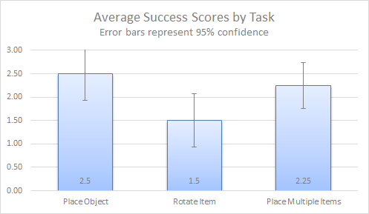
Figure 1. Average Success Scores by Task

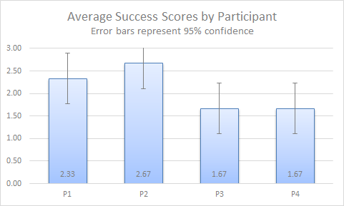
Figure 2. Average Success Scores by Participant

Most every participant expressed some level of disappointment or irritation during the second task where participants were given the task of first placing a piece of virtual furniture on the floor and then rotating that furniture using the application’s controls. Half of the participants expressed minor annoyance, but found the rotating action to be somewhat familiar to typical touchscreen controls of modern mobile devices. However, they noted that a major problem was a lack of instructions which forces users to rely heavily on cognitive recall from using the system over and over. The other two participants expressed more difficulty, taking more time to try different gestures and patterns. Success rates stayed relatively even across the board -- which may indicate that each participant expressed thoughts on the same issues. A few interesting findings were that participants were quick to learn how to place furniture through repetition from each task, but often struggled when trying to discover new features. Semiotics and previous experience with symbology/iconography/visual representatives proved useful such as the + symbol being mentioned as an intuitive symbol to “add furniture to the room” by two participants.

Task Issues
We recorded verbalized displays of frustrations to measure issues that occurred during the execution of the tasks. Combined with the issues mentioned during the interview, we are able to get a qualitative look at the issues encountered by each task. The counts are shown in Table 1.

Participant | Task 1 | Task 2 | Task 3
P1 | 2 | 1 | 0
P2 | 0 | 0 | 0
P3 | 1 | 1 | 0
P4 | 2 | 1 | 0
Table 1. Issues Encountered by Task

The main issues encountered and expressed by the users were: furniture placement/movement was confusing; sizing and ability to resize was not as expected; and the rotation mechanics are not intuitive. There were no recorded issues that arose from Task 3, potentially by learning from the experiences and frustrations brought by the first two tasks. Also, one participant didn’t encounter any issues throughout the tasks.

Participant Satisfaction

Task # | Participant | Q1 | Q2 | Q3 | Q4 | Q5 | Q6 | Q7
1 | P1 | 4 | 6 | 3 | 5 | 6 | 5 | 3
1 | P2 | 5 | 6 | 4 | 7 | 7 | 7 | 5
1 | P3 | 5 | 3 | 3 | 4 | 5 | 5 | 5
1 | P4 | 5 | 5 | 4 | 6 | 6 | 5 | 6
2 | P1 | 4 | 5 | 2 | 3 | 4 | 5 | 7
2 | P2 | 6 | 6 | 4 | 7 | 7 | 7 | 7
2 | P3 | 3 | 3 | 3 | 3 | 5 | 4 | 3
2 | P4 | 1 | 1 | 4 | 2 | 1 | 1 | 2
3 | P1 | 5 | 6 | 2 | 4 | 5 | 5 | 6
3 | P2 | 5 | 6 | 4 | 6 | 7 | 6 | 5
3 | P3 | 4 | 5 | 4 | 4 | 6 | 6 | 5
3 | P4 | 6 | 6 | 4 | 5 | 6 | 4 | 3
Table 2. Participant Scores for Questionnaire

In order to understand participant satisfaction, we calculated the ASQ scores for each participant after each task. It is important to note that this questionnaire inverted the standard ASQ scale, having 7 represent Strongly Agree instead of 1, and having 1 represent Strongly Disagree instead of 7. The ASQ scores for Task 1 were: 4.33, 5, 3.67, and 4.67. The ASQ scores for Task 2 were 3.67, 5.33, 3, and 2. The ASQ scores for Task 3 were 4.33, 5, 4.33, and 5.33. Overall, the average ASQ for Task 1 is 4.42, the average ASQ for Task 2 is 3.5, and the average ASQ for Task 3 is 4.75. See Q1-Q3 on Table 1 for individual scores.
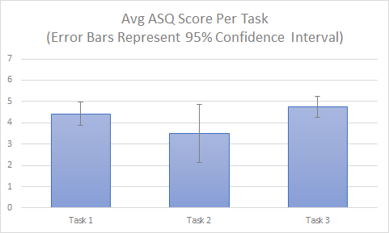
Figure 3. Average ASQ Score Per Task

A notable finding from the ASQ is that none of the participants gave Q3 a score greater than 4, showing dissatisfaction with the documentation in every task. One participant even noted the lack of documentation in the interview as an issue.

In addition to the ASQ, a supplementary question asked users to rank satisfaction with how the virtual furniture was represented in the real world environment on a seven-point scale, with 1 representing strong dissatisfaction and 7 representing strong satisfaction. The average score for Task 1 was 4.75, the average score for Task 2 was 4.75, and the average score for Task 3 was 4.75. This seems to show the participants attitudes toward the way virtual furniture looked in the real environment skewed toward satisfaction, though not perfectly. The individual scores show some participants were dissatisfied with how the virtual furniture was represented in the real environment for each task (see Table 1).

From the interviews, it seemed that overall the participants were satisfied with how the virtual furniture looked in the room. There was less satisfaction overall with the way they could move the furniture in the real environment, though a couple participants did report satisfaction in the interview. Participants noted issues like “non-responsiveness” and problems with rotating the furniture interfering with satisfaction. It is important to note that one participant was not asked the interview question measuring satisfaction with moving the furniture.

A few implications arise from these findings. It seems clear that users are dissatisfied with Task 2, as the average ASQ score is below a neutral score of 4. This suggests that there need to be improvements made in how users can rotate furniture. Results for Task 1 and Task 3 are more promising. It seems that users are at least somewhat satisfied with tasks that involve placing and moving virtual furniture in the real world, based on the ASQ scores. The other questionnaire data also provides evidence for this. However, these averages do show that there is room for improvement, and the interview data seems to confirm that there could be improvements made to the experience of arranging the furniture. Certain aspects of the app’s usability (such as rotation) need to be improved to increase user satisfaction.

Main Findings
The end results show that there is excitement for the mobile augmented reality space and that technically savvy users are able to adapt to and use the application for their needs without major issues. However, the lack of communication to the user about the application’s capabilities and functions were the greatest barrier to use.

Our findings show frustration at having to figure out the mechanics of movement and to overcome assumptions that run counter to the paradigms used by other applications on mobile devices. Shrinking the furniture is an example of this. It is not a feature that makes sense in the context of the app (no one can shrink a couch to make it fit better in their room), but it does make sense in the context of a mobile application (people resize virtual objects regularly). Making the functionality of the application more apparent would improve the app’s usability.

Some of this frustration seems to come from a lack of documentation or help offered by the app. The results of the evaluation indicate that the app lacks help that users need to learn how to use functions of the app. It seems that users expect cues of some kind, or would like some documentation they could easily find to get help using the app. The app as it currently exists does not give the users enough guidance to understand all of its capabilities.

Recommendations
Inform users how the size of virtual furniture is calculated and why it cannot be resized
The participants in our evaluation showed some form of confusion or lack of understanding on why the virtual furniture was presented at the size it was. Two of the four participants explicitly stated they thought the chairs were too big and expressed their frustration that they couldn’t resize the furniture.

A possible solution could be a temporary statement of the size dimensions and why they are the way they are when users attempt to resize the objects using gestures commonly associated with resizing actions in other applications.

Inform users how to position virtual furniture & inform users how to rotate virtual furniture
The controls for placing and manipulating the furniture are never shown through the use of the application.

Inform users why they need to scan their environments
There are times when the mobile augmented reality will require a rescan of the surface to be able to function. The app offers only a small instruction to move the mobile device around in order to accomplish this, but it doesn’t say what the objective of the scan is. Our recommendation would be to expressly tell the user what they are hoping to accomplish by doing this task, so they can understand how the application functions on the whole.

Reflection
This evaluation looked at the novel mobile augmented reality component of the IKEA Place app and how users unfamiliar with the technology would use it.

Successes
The tasks developed for this evaluation were crafted to deliver an increasingly complex use of features within the application. The gradual complexity introduced from task to task allowed us to evaluate the natural learning curve of the application as users may explore the ability of the apps. With the milestones we put in place and the metrics we recorded, we were able to isolate and evaluate the roadblocks that users may encounter in a natural progression.

The screen recordings were helpful in showing us the participants’ point of view of the application. Although the screen taps and swipes were not recorded, the movements were visual and the associated audio made clear of any hurdles or frustrations encountered.

Issues
This evaluation was not perfect. There were a few aspects of the project that could have been improved. A few details in the testing materials were inaccurate. There was a typo in the moderator script that changed the meaning of the instructions. The scale for the ASQ was inverted. While the team was able to find a way around these issues, these mistakes could have been avoided with more careful planning.

Another issue was that the way tasks were given to participants made it difficult to complete Task 2. Holding a piece of paper with task instructions while having to rotate a chair with 2 fingers was cumbersome, and caused issues for the users. In the future, a way around this may be to suggest to participants that they can set the paper down.

Appendix

Moderator Guide

Logistics
Before Study:
- Prepare scripts for moderator to use in the study
- Prepare and print consent forms for the participants to sign
- Create questionnaires in Qualtrics
- Prepare a location for the study
- Prepare a mobile device (for the tasks) and computer (for the questionnaires)

Before Each Session:
- Begin 30 minutes before the start of the study
- Ready room and devices by clearing the area and moving devices to their starting points
  - This may involve clearing caches or reinstalling apps
- Ready consent form for participant to sign. Prepare pen as well

During Each Session:
- Greet participant, and walk through introduction and consent form
- Instruct participant on the equipment and application being used today
- Start screen recording and audio recording
- Do task loop (3 tasks)
  - Give verbal instructions on the task
  - When task is completed, end screen and audio recording
  - Have user complete task-questionnaire
- Conduct post-study interview
- Ask participant for their feedback
- Thank participant and dismiss
- Move recordings to storage

Introduction Script
[Greet participant and offer them a seat]

Thank you for coming in for our study.

My name is Leah, and I’ll be working with you today. Also with us are Eugene, who will be taking notes, and Wen, who is the tech on standby, should any issues come up. Have you participated in a study before?

[YES] Great, then you may be familiar with some of the procedures used today.

[NO] That’s okay, I will explain everything that you will need to know to do the study.

For the majority of our study, I will be reading directly from this script to make sure that my instructions are the same to you as they are to all of the participants in this study.

This study is being conducted as part of a group project for our class, INLS 719 - Usability Testing. Today you will be asked to complete THREE tasks that involve using augmented reality through a mobile device.

We will ask you to complete questionnaires after each task, and if you agree, we will be recording the session for further analysis later. Lastly, there will be a short interview after you have completed all of the tasks.

Before we begin, can you please put your phone in silent mode so that the study will not be interrupted?

[YES] Thank you.

[NO] I can understand a need to be in reach of someone at any given time, but there is a need to have your full attention for the tasks we will ask you to do today. Could we reschedule for a time that you would be able to give your full attention to the study?

During the study if you need to take a break to go to the restroom or get some water, that is perfectly fine, but we ask that you wait until you are between a task to do so. Is this okay with you?

[YES] Thank you.

[NO] Are there any accommodations we can make for you so that you would be able to give your full attention to the tasks in the study today, such as a water bottle or longer breaks?

Consent Script
Before we begin the study, we will need to discuss consent. I will now give you 2 copies of the consent form. One form is for us and the other is for you to keep as a reference. Before I give you a chance to read the consent form in full, I would like to cover some main points with you.

[Give participant 2 copies of the consent form and a pen. Then read the following]

- We will record your interaction with the application through the use of screen recording technology.
- We will also use audio recorders to record the audio of your think-aloud comments.
- Your participation in this study is completely voluntary. You may choose not to participate, or you may withdraw your consent at any time without penalty.
- It will take about 20-30 minutes to complete this study.
- The recordings will only be used for the purpose of analyzing the system you are using and will not be associated with your name or any other identifying information. These recordings will be deleted at the completion of this study.
- None of the information we store will be associated with your name. We will assign you a participant number that will be used to keep track of your data. The participant number will not be stored with your name.

Now please take as much time as you need to go through the consent form. If you have any questions, please let us know. When you are finished and you agree, please sign both copies of the form and let me know you are finished reading it.

[YES to consent] Thank you. [Take 1 copy of the form]. We can now begin the study.

[NO to consent] I understand that you are not consenting to the terms of the study. We are unable to proceed with the study without the signed consent form, but we want to thank you for coming in today.

[Consent Form included at the end of this document]

Task Script
To perform the tasks today, you will be given a mobile device. This device is able to run the application we are testing and the screen recording technology we will use to record the tasks. The application you will be using is IKEA Place. This application allows you to try out furniture by using mobile augmented reality to place virtual pieces of furniture in your real life surroundings.

Do you have any experience with the device mentioned before, or a similar device?

[YES] Great. Then the use of the device may be familiar to you.

[NO] No problem. We will walk you through the basics of the device and be available to any questions you may have about it.

Do you have any experience with the IKEA Place application mentioned before, or a similar application that allows you to interact with virtual items using augmented reality?

[YES] Thank you.

[NO] No problem.

For each task, you will be handed a task description card, which we will ask you to read aloud. If you have any questions before beginning the task, please let us know. When you are ready, you will be given the device from the starting state and told that you may begin. You may refer back to the card at any time, or ask any questions that may come up, but we may be unable to answer a question until after the task is finished if the answer would directly tell you how to accomplish the task. While completing the task, try to share your thought process aloud. This helps us understand how you perceive the system.

If you signal completion of the task by meeting all of the requirements, you will be asked to hand back the device and fill out a questionnaire. I will ask you if you need a break and when you are ready to proceed, we will move on to the next task, or after all the tasks, the post-study interview.

The purpose of this test is to evaluate how well IKEA Place works as an app; we are not testing you or your abilities.

For Each Task Script
To begin the [first/second/third] task, please move over here to the user marker. You will start the task off standing on this marker, though you are free to move around after the task is complete. Please try to think aloud as you complete the task.

Here is your task on a note card. Please read the task aloud and afterwards let us know if you have any questions or if you are ready to begin.

[Participant indicates readiness to begin]

[Start the device recording. Give Participant device. Start timer. Answer questions when they arise. When time is up, or participant indicates they are done, take the device back.]

Thank you. Please move to the computer and complete the questionnaire.

[Participant completes the questionnaire]

Post Tasks/Interview Script
[Note for moderator: Remind participants of tasks if they have trouble remembering. Don’t be afraid to probe with “Could you tell me more?” if necessary.]
Those are all of the tasks we have for you today. What I will do now is conduct a short interview asking you about your experiences in our study today. Please know that for this part, I will be reading from my script, so there is a chance that you may have already answered a question I will ask.

During your use of the application,...
- Did you have a positive experience with the application?
- Did you gain an understanding of what this application could do?
- Do you feel this application provided you with the knowledge and skills you needed to be confident in its use?
- Did placing the furniture in the room go as you expected it to?
- Were you satisfied with the way the furniture looked in the room?
- Were you satisfied with the way you could arrange furniture in the room?
- Was there anything difficult about using the application? If there was, what was difficult?
- Would you use this app to preview how furniture would look in your house? Why or why not?
- Do you feel like you were able to complete each task with the app? Why or why not?
- Do you have any questions or comments about this study?

Post Interview Script
That’s all the tasks and questions we have for you today. We’d like to thank you for participating in our study today. If you have any further questions about your participation or our study, please contact us through the research contact’s email address found on your copy of the consent form.
Consent Form

What is the Purpose of this Study?
- You are being asked to participate in a study conducted by the group The AR Heels for the class INLS 719 for the Fall 2018 semester.
- This study looks at aspects of usability of the IKEA Place mobile app. The information gained will be used to analysis the strengths and weaknesses of components of this application.

Your Participation
- Your participation is completely voluntary.
- You will not be compensated for your involvement.
- This study session should not last longer than 30 minutes.
- You will be using an augmented reality mobile phone app for this study. These task will require looking through a mobile phone to view virtual furniture that will appear to exist in the study room. You will be tasked with positioning and orienting the virtual furniture in the room.
- You do not need prior experience with this mobile app in order to participate.
- You may take a break during the study at any time.
- You may withdraw your consent and end your participation at any time.

Privacy Considerations
- You will not be identified by name in reports or analyses generated by this study.
- You will be assigned a participant ID that will be only be used for data analysis, but your name will not be associated with the participant ID.
- Your questionnaire answers will be stored securely through the Qualtrics online platform. This data will be deleted in full after the conclusion of the study
- Screen recordings of your use of the device will be secured on the study mobile device until they are transferred to Onedrive. This data will be deleted in full after the conclusion of the study.

You have the right to ask any question of the researchers conducting this study. If you have any questions or concerns after the study, you may reach out to the study contact listed below.

Research Contact: Leah Ramsier Email Address: leaheryn@live.unc.edu

Participant’s Agreement
I agree to participate in the study conducted by the The AR Heels. I understand that the answers I provide to their questions and the data I provide by completing their tasks will be used to analyze usability concerns in the IKEA Place mobile app.

I consent to the creation and use of the screen and audio recording by the The AR Heels. I understand that this information and recording is for research purposes only and that the recordings will be deleted on completion of the study.

I voluntarily agree to participate in this research study.

PRINT NAME: ______________________________________________ DATE: _____________

SIGNATURE: ______________________________________________
Tasks

The following three pages are the tasks presented to the participants. Each task was given to the participant on a half sheet of paper. The first task also included a scenario to get the participants into the mood of the tasks.

[Please read the Scenario and the Task aloud. Let the Moderator know when you are ready to begin]

Scenario: Imagine you just moved to a new apartment and you need to purchase furniture for your new home office. You remember from your last visit to IKEA that they had several nice pieces of furniture. Before you purchase the item online, you’d like to use the IKEA Place Augmented Reality App to make sure it matches your expectations for how it would look and fit in your home office.

Task 1: While standing on the USER marker, use the app to find the Markus chair and place it in the room on the CHAIR marker.

Steps:
- Open App
- Click + button
- Click magnifying glass and search for “Markus”
- Click the Markus office chair in the beige color.
- Click “Try in your place”
- Scan area as prompted
- Click the check button to place virtual furniture in the room on the CHAIR marker

[Please read the Task aloud. Let the Moderator know when you are ready to begin]

Task 2: While standing on the USER marker, use the app to find the Markus chair and place it in the room on the CHAIR marker, in the orientation indicated by the marker.

Steps:
- Open App
- Click + button
- Click magnifying glass and search for “Markus”
- Click the Markus office chair in the beige color.
- Click “Try in your place”
- Scan area if prompted
- Click the check button to place virtual furniture in the room on the CHAIR marker
- Use the screen to rotate the chair so that it is aligned with the direction the marker indicates
- While holding the device towards the virtual object, move from the initial USER marker to the second USER marker

[Please read the Task aloud. Let the Moderator know when you are ready to begin]

Task 3: While standing on the USER marker, use the app to find the Markus chair and place it in the room on the CHAIR marker. Do the same for Micke desk on the DESK marker and the Hektar lamp on the LAMP marker.

Steps:
- Open App
- Click + button
- Click magnifying glass and search for “Markus”
- Click the Markus office chair in the beige color.
- Click “Try in your place”
- Scan area as prompted
- Click the check button to place virtual furniture in the room on the CHAIR marker
- Repeat steps 3-7 for the “Micke” desk in white and place it on the DESK marker
Repeat steps 3-7 for the “Hektar” lamp in dark gray and place it on the LAMP marker

Post Task Questionnaire

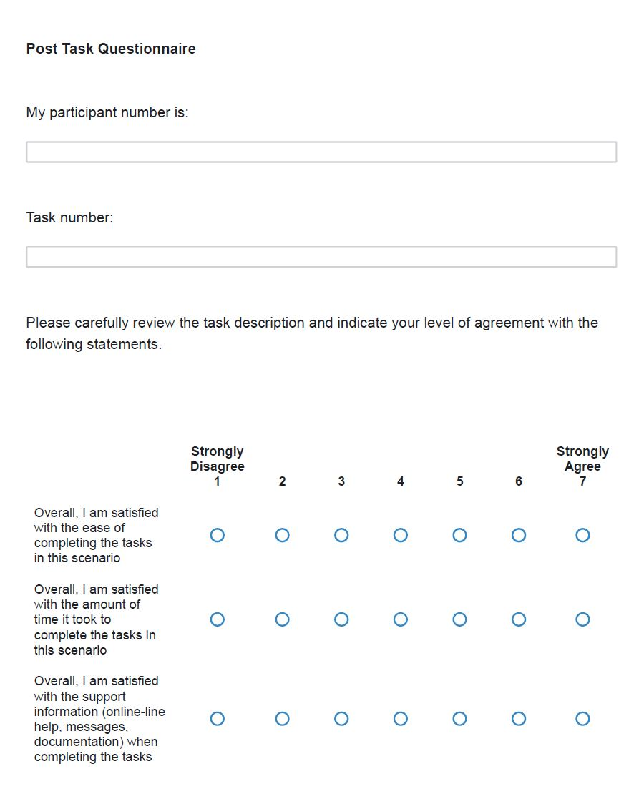

Post Task Questionnaire (p2)

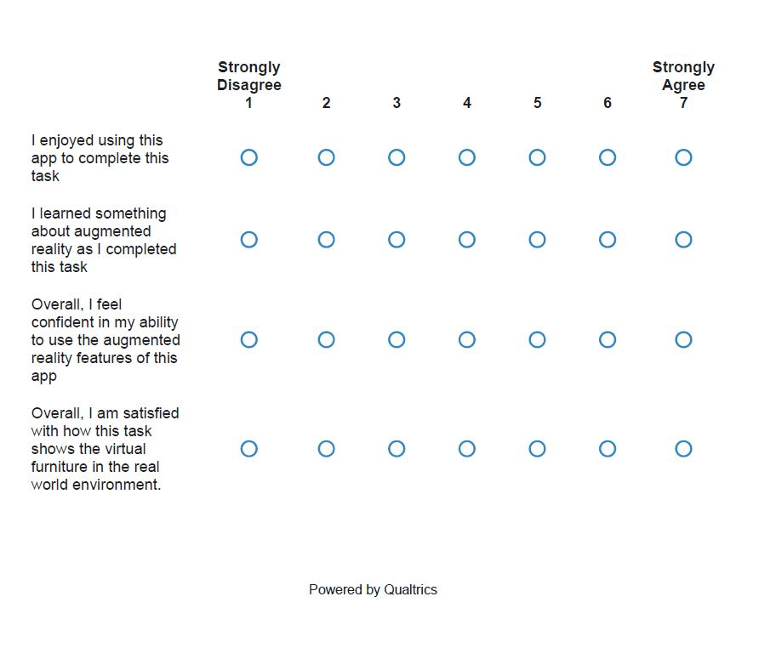

Post Study Interview

Included in the Moderator Guide, but repeated here for clarity.

During your use of the application...
- Did you have a positive experience with the application?
- Did you gain an understanding of what this application could do?
- Do you feel this application provided you with the knowledge and skills you needed to be confident in its use?
- Did placing the furniture in the room go as you expected it to?
- Were you satisfied with the way the furniture looked in the room?
- Were you satisfied with the way you could arrange furniture in the room?
- Was there anything difficult about using the application? If there was, what was difficult?
- Would you use this app to preview how furniture would look in your house? Why or why not?
- Do you feel like you were able to complete each task with the app? Why or why not?
- Do you have any questions or comments about this study?

