Text:
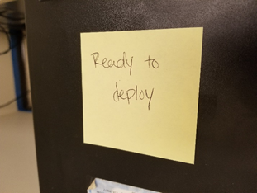
Icon:
Source: https://thenounproject.com/search/?q=computer&i=716202

Category: Information
Lets employees know this computer is ready to be deployed
Does this relate to Pritoni’s description of usability? No, this is not related to usability, but instead provides information for employees so they know that it is okay to deploy a machine.
Where: Computer in the School of Information and Library Science
Who: SILS IT Department
Additional Information: This helps people in the IT department know if a machine has been re-imaged and is ready to be deployed in its newly assigned location.

Text:
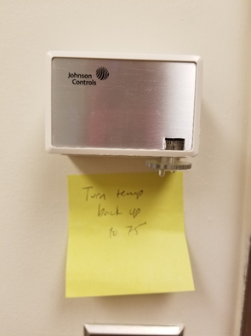
Icons:
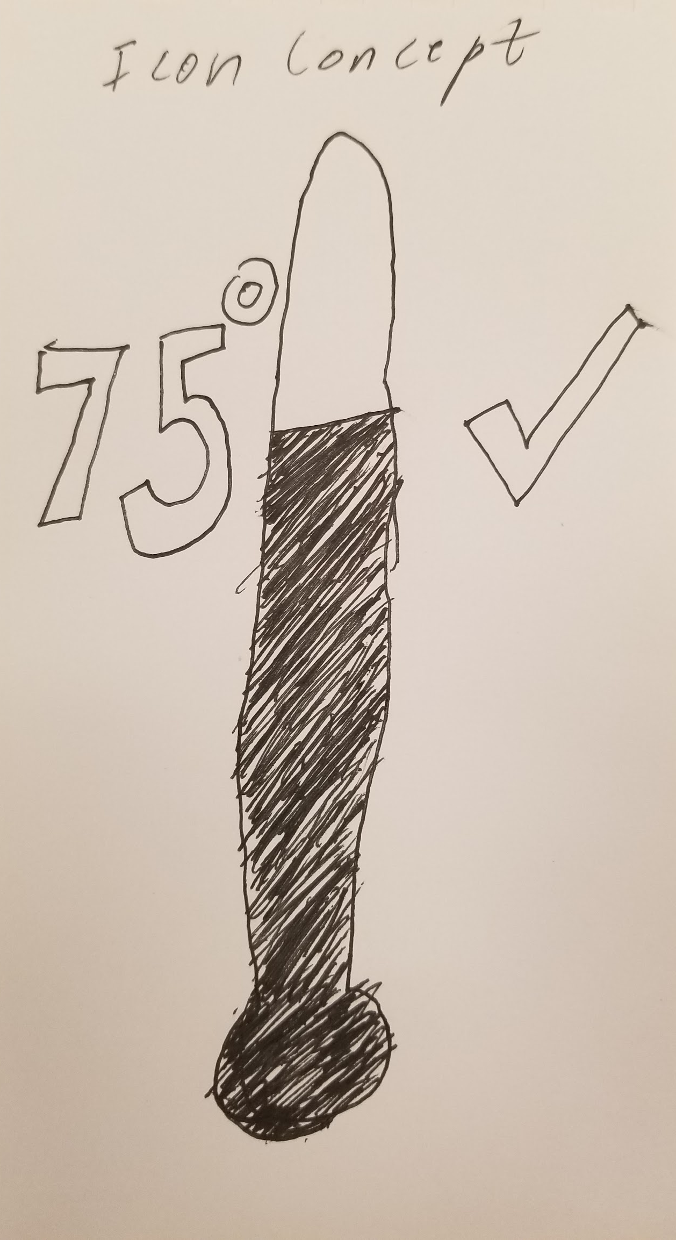

Category: Preferred/Optimal setting
Lets people know the preferred temperature setting for the room
Does this relate to Pritoni’s description of usability? This does not, since it does not describe how to use the thermostat, but instead gives a preferred setting. This label isn’t giving information on how to use the device.
Where: Thermostat in Room 09 in Manning Hall
Who: People who use Room 09
Additional Information: This helps people know that temp should be set back to 75 degrees. I don’t know the reasoning behind this.
Text:
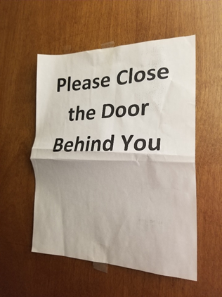

Icons:
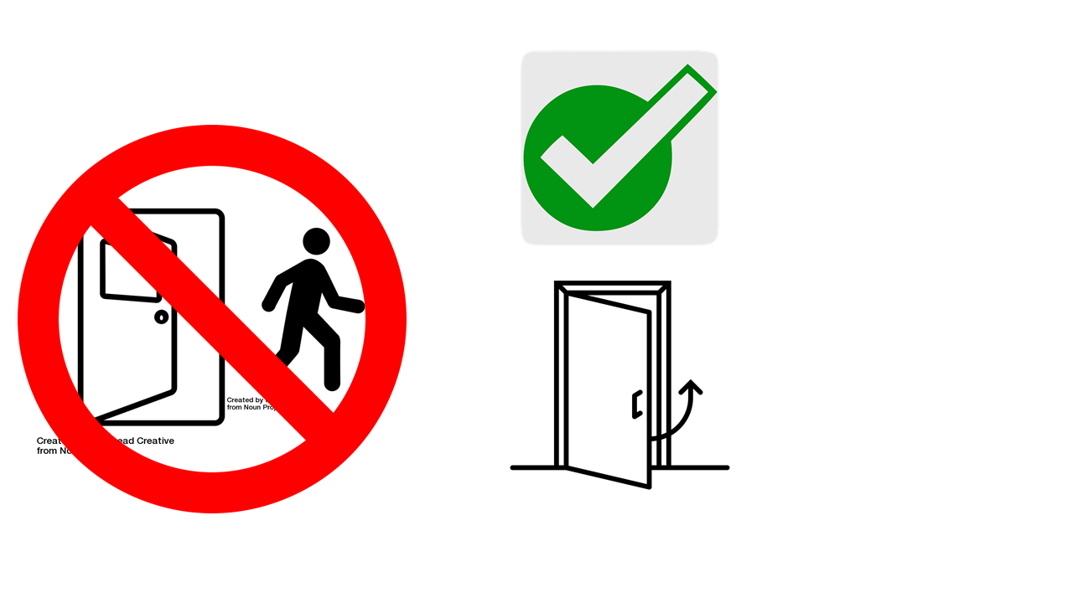
Open Door: https://thenounproject.com/search/?q=open%20door&i=2310660
Person: https://thenounproject.com/search/?q=person%20walking%20out&i=19727
No Symbol: https://pixabay.com/vectors/no-symbol-prohibition-sign-39767/
Check Mark: https://pixabay.com/illustrations/correct-mark-green-continue-right-2214020/
Closing Door: https://thenounproject.com/search/?q=door%20close&i=138058

Category: Guidance – Encourage Behavior/Reminders
This reminds users to close the door when they leave the room
Does this relate to Pritoni’s description of usability? No, this doesn’t relate to the usability of a system.
Where: Room 214 in Manning Hall
Who: People using Room 214
Additional Information: This reminds people to keep the door closed so that people without access to the room can’t sneak in.

Text:
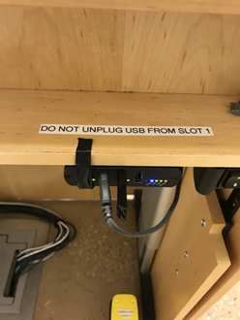

Icon:
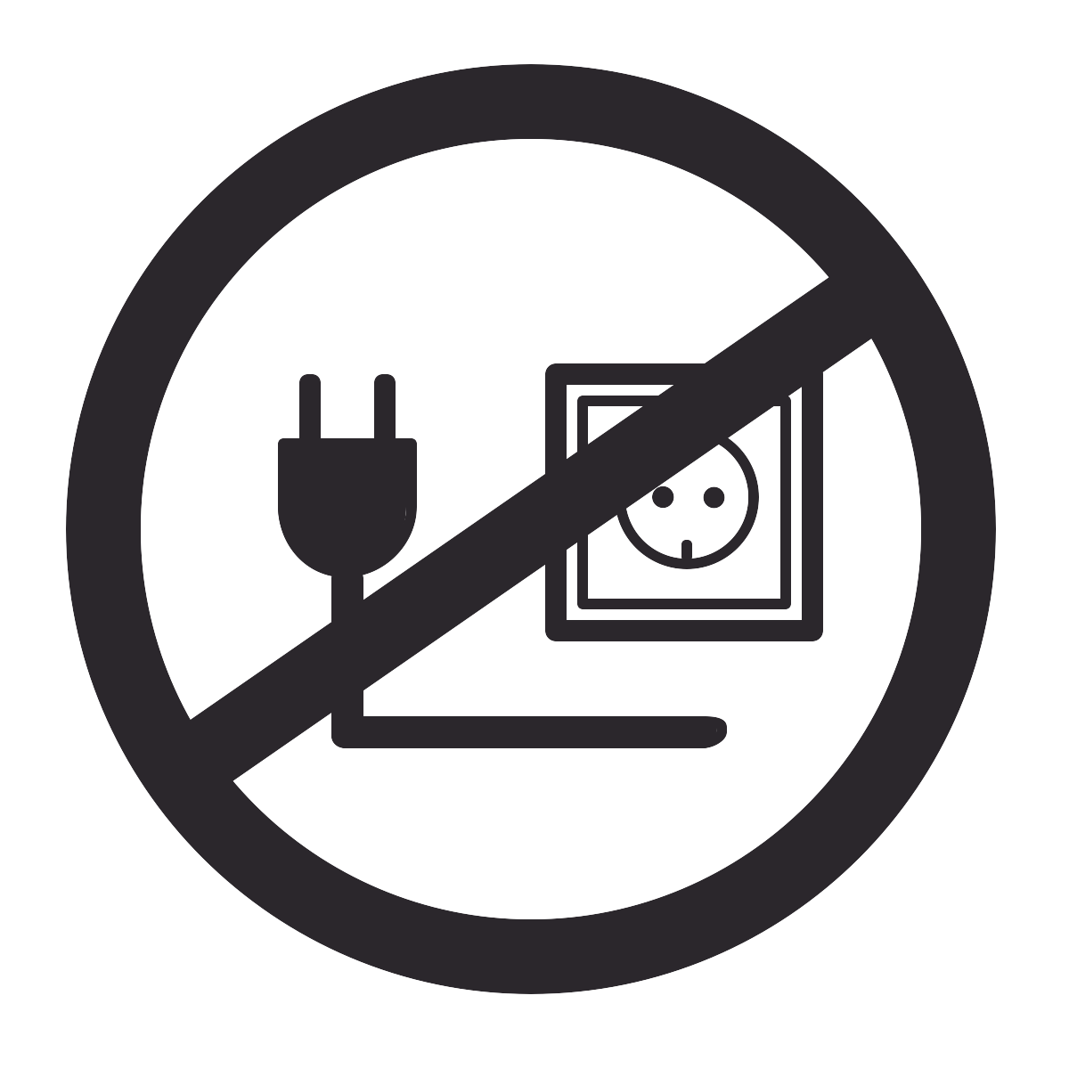

Icons from The Noun Project.

Category: Instructions for Operation
Unplugging the USB would affect/turn off the display totally.

Does this relate to Pritoni’s description of usability? Yes

Where: GSB G100
Who: professors who teach in this room
Additional information: the projection is complicated and carefully set up to make presentation easier for professors.

Text:
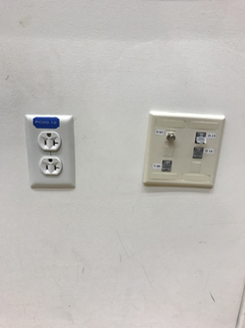

Icons:

Icons from The Noun Project.

Category: Assignment
The outlets are being mapped to something within the electrical infrastructure of this lecture hall (presumably!).

Does this relate to Pritoni’s description of usability? No

Where: GSB G100
Who: Electricians working in this room
Additional information: n/a
Text:
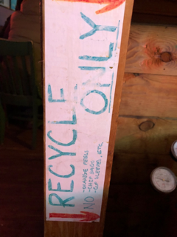

Icons:
Category: Assignment
The can is being identified as just for recycling.

Does this relate to Pritoni’s description of usability? No

Where: Restaurant/bar
Who: Employees/guests
Additional information: There is no need for large amounts of text; a simple “recycle” icon will do just fine!

Text:

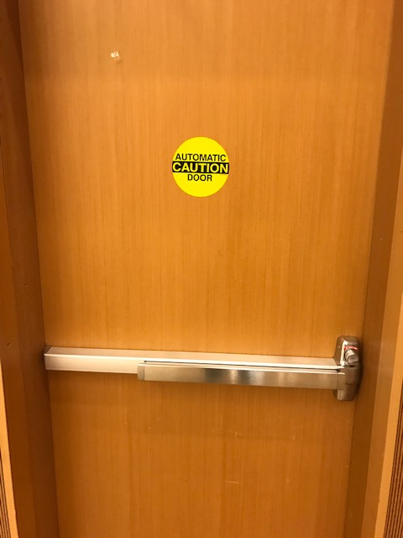

Icon:

Icons from The Noun Project.

Category: Guidance
The sticker tells the user that the door is capable of opening by itself.

Does this relate to Pritoni’s description of usability? No.

Where: Classroom
Who: Any occupant of the lecture hall
Additional information: N/A

Text:

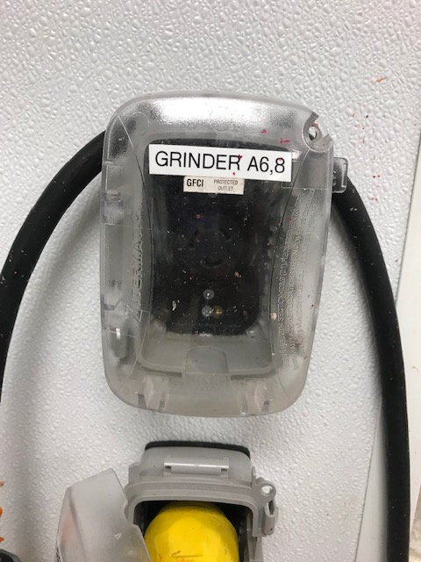

Icons:

Icons from The Noun Project.

Category: Assignment
The label assigns this outlet to the grinder

Does this relate to Pritoni’s description of usability? No.

Where: Clean Juice
Who: Cold-presser using the grinder
Additional information: N/A

